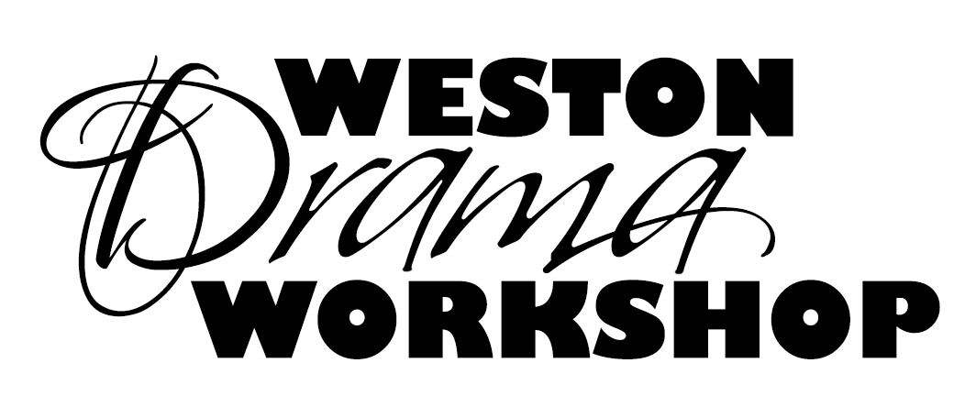
WESTON DRAMA WORKSHOP
Internship Application (Second Year)
Summer 2018

Weston Drama Workshop will offer a limited number of internships for the Summer 2018 Season to last year’s intern cohort (high school juniors, seniors, and college students).
These will be selected based on the application and interview process. Please complete the application by typing responses directly into the document below and emailing it to: westondramaworkshop.info@gmail.com by Thursday, February 15, 2018.

Applicants will be contacted by a member of the Producing Team to schedule an interview after all applications are reviewed.

First Name:

Last Name:

Nickname (if any):

Today’s Date:

Age, Birthday:

Current School and Grade or College and Level:

Contact Phone, Parent Contact Phone:

Contact Email, Parent Contact Email:

Major areas of interest (rate them from 1 being most interest to 10 being least interest)

____ Theatre Administration

____ Stage Management

____ Marketing

____ Directing

____ Costumes

____ Scenic

____ Lighting

____ Sound

____ Props

____ Choreography

Theatrical Experience:
Please list past theatrical experience. Please speak specifically to any experiences within this last year with Theatre Administration, Stage Management, Marketing, Directing, Costumes, Scenic, Lighting, Sound, Props, Scenic Painting. You may also attach a resume if you would like.

Statement of Purpose:
Why are you applying to be an intern for a second year? (Word Limit: 500 Words)

Questions to Consider:
Last year’s internship had three components: Your Specific Job Assignment, the Intern Group Projects, and a Production Assignment. In reflecting on your goals for last year, which were attainable and which were more challenging? Why?

In the spirit of growth and development, how would you approach a second year as intern?

Anticipating that there could be more applicants building on last year’s success, what could you bring to the table that may distinguish yourself from others?

How will you make your time interning with WDW most productive?

What lasting creative legacy will you leave to enhance WDW’s future?

Conflicts:
Please list all conflicts between June 3rd and July 29th, 2018

No letter of recommendation is required as we have last year’s reference on file.

