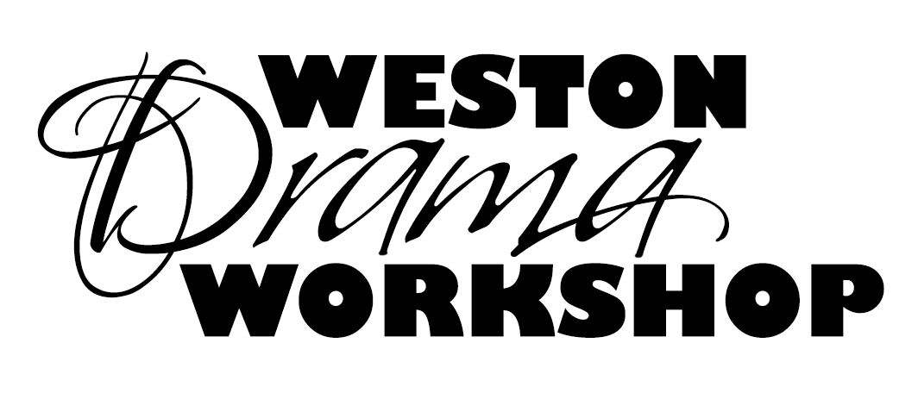
WESTON DRAMA WORKSHOP
Internship Application (First Year)
Summer 2018

Weston Drama Workshop will offer several unpaid internships for the Summer 2018 Season to high school juniors, seniors, and college students. These will be selected based on the application and interview process. Please complete the application by typing responses directly into the document below and emailing it to: westondramaworkshop.info@gmail.com by Thursday, February 15, 2018.

Applicants will be contacted by a member of the Producing Team to schedule an interview after all applications are reviewed.

First Name:

Last Name:

Nickname (if any):

Today’s Date:

Age, Birthday:

Current School and Grade or College and Level:

Contact Phone, Parent Contact Phone:

Contact Email, Parent Contact Email:

Major areas of interest (rate them from 1 being most interest to 10 being least interest)

____ Theatre Administration

____ Stage Management

____ Marketing

____ Directing

____ Costumes

____ Scenic

____ Lighting

____ Sound

____ Props

____ Choreography

Theatrical Experience:
Please list past theatrical experience. Please speak specifically to any past experiences with Theatre Administration, Stage Management, Marketing, Directing, Costumes, Scenic, Lighting, Sound, Props, Scenic Painting. You may also attach a resume if you would like.

Statement of Purpose:
Why are you applying for this internship, and what do you hope to get out of it? What are your major areas of interest? What would a successful internship look like for you? (Word Limit: 500 Words)

Short Answer Questions:
Which skills are your strengths? What will you need to work on if accepted into the program?

What additional skills/knowledge can you bring to support WDW and its programs?

How will you make your time interning with WDW most productive?

What lasting creative legacy will you leave to enhance WDW’s future?

How do you plan to grow from this internship opportunity?

What do you hope to take away from this experience?

Conflicts:
Please list all conflicts between June 3rd and July 29th, 2018

Letter of Recommendation
From a theater teacher, director, or other theatre professional with whom you have worked. Please make sure they include their name, email, phone, etc. in the letter. This should be emailed directly to WDW at westondramaworkshop.info@gmail.com. Please make sure they reference your name in the subject line of the email.

